# Exercise - Install iNZight

**In this exercise you will download and install iNZight, a free software package used throughout this course. You will be guided to:**

1. Download and install iNZight onto your computer.
2. Start iNZight.

* [Alternative version of this Exercise for **using R** (not iNZight) is linked here](https://www.stat.auckland.ac.nz/~wild/d2i/exercises/1.10%20exercise-install-R_17.pdf).

[***iNZight Lite*** does not require installation and is the better option if you cannot install software, have only a tablet, or a large download is a problem. This link [lite.docker.stat.auckland.ac.nz](http://lite.docker.stat.auckland.ac.nz/) takes you straight into the program. See also Lite’s [getting started video](https://www.stat.auckland.ac.nz/~wild/iNZightLite/IntroMovie.html).]

## INSTRUCTIONS

You may prefer to [**print the instructions**](https://www.stat.auckland.ac.nz/~wild/d2i/exercises/1.10%20exercise-install-inzight_16.pdf).

## 1. Install iNZight

Go to the **[iNZight homepage](https://www.stat.auckland.ac.nz/~wild/iNZight/)**, click the **“Download” button** and follow the instructions given there. (It may be helpful to right-click on the iNZight homepage link and open it up in a new browser page to make it easy to see both this page and the iNZight page.)

The installation process depends upon what operating system you are using (e.g Windows or Mac). iNZight is hosted by the University of Auckland and is safe to use. You may need to change your settings to accept this software from an unknown user.

You should install the current version of iNZight, **version 3.0**. This is a major upgrade from previous versions of the software and requires a new installation, not just an update. [If for some reason you are not able to install the software, e.g. you want to work using an ipad or Android tablet, almost all of the exercises can be done online using the web apps **[iNZight Lite](http://lite.docker.stat.auckland.ac.nz/)** and **[VITonline](https://www.stat.auckland.ac.nz/~wild/VITonline/)**. These do not require installation.]

**If you have a problem installing iNZight**, follow these steps:

* First, look for a solution in **[iNZight’s FAQ for Download and Installation issues](https://www.stat.auckland.ac.nz/~wild/iNZight/support/faq/?section=download)**.
* Second, if you cannot find the solution to your problem in the FAQ,[**send a message**](https://www.stat.auckland.ac.nz/~wild/iNZight/support/contact/) to the iNZight team ([Tom](https://www.futurelearn.com/profiles/584227) and [Chris](https://www.futurelearn.com/profiles/285641)). In the meantime you can use [iNZight Lite](http://lite.docker.stat.auckland.ac.nz/).

## 2. Start iNZight

A normal installation of iNZight on Windows leaves a shortcut icon like that above on your desktop. Double click to open iNZight. It may take as much as 20 seconds to load. On Mac iNZight will be in your applications folder. When iNZight opens up you should see:

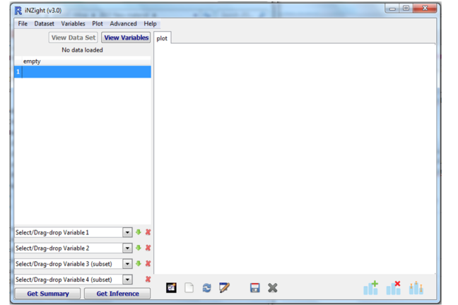

The left side of the window is for data and variables and the right side is where plots will be displayed. You can resize each part by dragging the line between the two screens or dragging the corner of the entire window to adjust the size. For more information, see:

* [Starting iNZight](https://www.stat.auckland.ac.nz/~wild/iNZight/user_guides/basics/getting_started.php)
* the short [getting-started video here](https://www.stat.auckland.ac.nz/~wild/iNZight/user_guides/basics/?topic=load_data).
* [Navigating the interface](https://www.stat.auckland.ac.nz/~wild/iNZight/user_guides/interface/).

When iNZight is open, you will see **an additional ‘Console’ window**. There is no need to use this window but if you close it, iNZight will close.

## Common Questions

***What is VIT*?**  
VIT is software (built with many of the same building blocks as iNZight) that we will use in Weeks 5-7 to build statistical concepts .

***How do I update iNZight?***  
Go to <https://www.stat.auckland.ac.nz/~wild/iNZight/user_guides/basics/?topic=update_inzight>

***In the R version of this Exercise I am having trouble with installing the iNZightPlots and FutureLearnData packages***

On some systems copy and paste from the pdf does not work reliably. You may see that the url address breaks over 2 lines with /R on another line. *If you are having problems copy the code from*[***here***](https://www.stat.auckland.ac.nz/~wild/d2i/exercises/1.10%20exercise-install-R_17.txt) instead of the pdf.